AR FINAL PROJECT REPORT: AR SEA BATTLE
1. Group Information
Group Number: 13

Your Name and Surname: Arsenije Djordjevic

All Group Members:
- Arsenije Djordjevic

2. Project Links
GitLab Repository URL: https://gitlab.com/Arssa02/arseabattle
Project Demo Video URL: __________________________________________

3. Project Overview
3.1 Project Description
AR Sea Battle is a two-player Augmented Reality implementation of the classic Battleship board game developed in Unity using the Vuforia Engine. The application uses image tracking to place two virtual 5×5 game boards on top of printed image markers.
Players take turns placing ships on their own board, pass the phone to the other player, exchange physical markers, and then alternate attacking each other's fleet. The application combines AR visualization with a traditional board game while demonstrating image tracking, user interaction, game state management, and mobile deployment.

3.2 Target Platform
Specify clearly:
☐ Desktop
X Mobile AR (Android / iOS)
☐ Meta Quest
☐ HoloLens
The application was developed for Android devices using Vuforia image tracking. Two printed image targets are recognized by the camera and used as anchors for spawning the virtual game boards.

4. Technologies and Tools Used
Unity Version: 6000.3.9f1 (Unity 6)
AR Framework (Vuforia/AR Foundation/ARCore/ARKit/Meta XR/MRTK): Vuforia Engine 11.4.4
Programming Language: C#
3D Modeling Tools (if any): None
Version Control: GitLab
Other Tools (e.g., Visual Studio, Figma, Photoshop, Illustrator): Visual Studio Code, Git, Git Bash

5. System Architecture
The project consists of a single Unity scene containing the AR Camera, Player 1 Image Target, Player 2 Image Target, GameManager, UI Canvas, and AudioManager.
The application is divided into several script groups:
Game Logic: GameManager, OceanBoard,Player, Ship, Cell
UI: GameUI, PlacementUI
Audio: AudioManager
Vuforia Image Targets initialize the virtual boards when the markers are detected, while GameManager controls the overall game flow, including ship placement, player turns, shooting, and victory conditions.
6. Main Features
Image Tracking
Two Vuforia image targets are used to create independent AR game boards.
Object Placement
A virtual 5×5 board is generated dynamically when a marker is detected.
UI Interaction
Players use dropdown menus and buttons to place ships and perform attacks.
Audio Integration
Different sounds are played for: ship placement, hit, miss, ship sunk, victory
Particle Effects
Particle systems provide visual feedback for successful hits and misses.
Game Logic
The application supports: ship placement validation, turn management, hit detection, ship sinking, victory detection, restart functionality

7. Screenshots
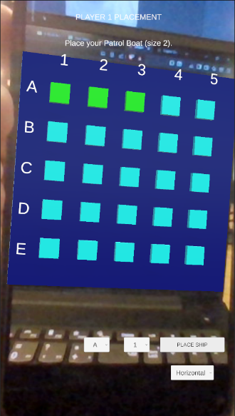
Figure 1. Player 1 placing ships
Figure 2. Battle phase
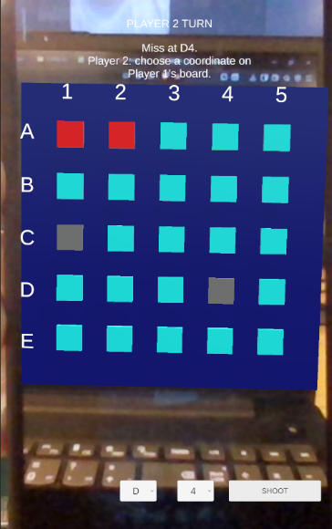

Figure 3. Game Over screen
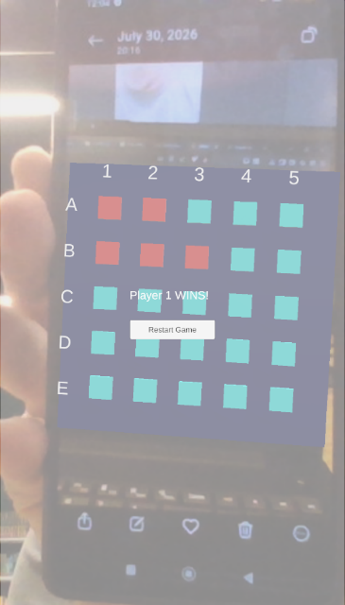
8. My Role in the Project
I designed, implemented, tested, and deployed the complete application. My responsibilities included AR integration, gameplay programming, UI implementation, debugging, Android deployment, and version control.
9. My Contribution
- Implemented the complete Battleship game logic, including ship placement, turn management, hit detection, and victory conditions.
- Integrated Vuforia Engine and dynamic image-target-based board generation.
- Designed and implemented the user interface, pass-the-phone workflow, coordinate labels, audio, and particle effects.
- Tested and deployed the Android application while maintaining the GitLab repository.
10. Workload Distribution
Group Member | Role | Contribution (%)
Arsenije Djordjevic | Developer | 100%
Total must equal 100%.

11. Challenges and Solutions
Challenge 1 – Reliable Image Tracking
One image target had noticeably weaker tracking than the other. It was replaced with a new target containing more distinctive visual features, resulting in faster and more stable recognition.
Challenge 2 – Pass-the-Phone Gameplay
Since the game is played on a single device, clear transitions between players were required. A countdown and pass-the-phone panel were added to guide players through each phase.
Challenge 3 – User Interface
Combining AR visualization with traditional UI controls required several iterations. The interface was refined to improve readability, feedback, and ease of use on a mobile device.
Challenge 4 – Visual Clarity
The detailed image markers made the virtual board difficult to distinguish. An ocean base and slightly raised cells were added to improve contrast and create a more three-dimensional appearance.
Challenge 5 – Version Control
The Vuforia Unity package exceeded GitLab's file size limit. The repository was reorganized so large generated files were excluded while preserving the project's functionality.

12. Conclusion
This project provided practical experience with Augmented Reality application development using Unity and Vuforia. Throughout development I improved my understanding of image tracking, game state management, user interface design, Android deployment, and software version control.
Future improvements could include 3D ship models, gesture-based interaction instead of UI controls, online multiplayer support, and enhanced visual effects.
The final application was successfully deployed and tested on an Android device, demonstrating stable AR image tracking and complete gameplay functionality.

